David L. Suddjian
Biological Consulting Services

801 Monterey Avenue, Capitola, CA 95010
Telephone 831· 479· 9603, email dsuddjian@aol.com

Summary of 2003
Marbled Murrelet Monitoring Surveys

In The Santa Cruz Mountains

Prepared for

Command Oil Spill Trustee Council
Attn: Steve Hampton
Office of Spill Prevention and Response
California Dept of Fish and Game
PO Box 944209
Sacramento, CA 94244-2090

Prepared by

David L. Suddjian
Biological Consulting Services
801 Monterey Ave., Capitola, CA 95010

March 31, 2004
Final Report
INTRODUCTION

This report presents the results of Marbled Murrelet (Brachyramphus marmoratus, hereafter referred to as “murrelet”) monitoring surveys conducted in 2003 for the Command Oil Spill Trustee Council (COSTC) at Portola Redwoods State Park, Butano State Park, and San Mateo County Memorial Park (Figure 1). These surveys were commissioned to assist the COSTC in restoration planning for potential projects benefiting the Marbled Murrelet. To further assist in this planning, the report also references results from additional surveys conducted at Portola and Big Basin Redwoods State Park under a separate contract for the California Department of Fish and Game (CDFG) as part of on-going long term monitoring study (Suddjian 2003b) (Figure 1).

Methods

Study Design

The CDFG has funded on-going murrelet monitoring at Portola and Big Basin since 1992 and 1995, respectively. CDFG’s existing program at Portola included surveys at one station on three consecutive mornings in late June or early July, with data collected in 1992-1995, 1998 and 2001-2003 (Suddjian 2003b). The existing program at Big Basin included surveys at five stations, with data collected in 1995, 1996, 1998, and 2001-2003 (Suddjian 2003b). During 1995, 1996 and 1998 the monitoring at Big Basin had five surveys annually at each station from May to early August, with two in July. Coverage was subsequently truncated due to limited funding, and from 2001-2003 there have been just three surveys annually at each station from mid-June to late July, with two in July.

The monitoring surveys funded by COSTC augmented the existing monitoring by expanding coverage at Portola, and adding coverage at Butano and Memorial, so that all stations in each park were surveyed three times annually from June to July, with two surveys at each in July. Two new stations were established at Butano and Memorial, and one new station was established at Portola.

Location of Survey Stations

Proper survey station placement is critical to permit an observer’s ability to hear or see murrelets (O’Donnell 1995, Pacific Seabird Group 2003), and landscape scale topography may also affect murrelet activity at a given location (Miller and Ralph 1995). Criteria were established to guide selection of new monitoring stations.

Primary Criteria:

- A station should be in suitable murrelet nesting habitat in an area known to support murrelet activity. In some cases, depending on patterns of murrelet activity at a site, the nature of available habitat, and access, a station might be located adjacent to suitable nesting habitat or in forest with residual old growth trees that is not optimal habitat. Existing knowledge of murrelet occurrence in the parks guided application of this criterion (D. Suddjian pers. obs., S. Singer pers. comm., G. Strachan pers. comm., CDFG 2000)

- A station should be within a significant canopy gap that provides a large view of the sky overhead. Gaps might be created naturally (i.e., by a stream corridor, landslide, or large tree fall), or by humans (i.e., openings over a road or campground).

- A station should be near a stream, in a valley bottom, or relatively low on a side slope. Ridgeline locations should be avoided.

- A station should be located where ambient noise from streams or roads does not significantly prohibit auditory murrelet detections within 200 meters of the station.

- At least one station in each park should be within or immediately adjacent to a main campground as the COSTC may propose a project to conduct corvid management activities at campgrounds. Survey stations close to campgrounds may help document the presence of marbled murrelets in the area and prioritize which campgrounds may need predatory control.

Secondary Criteria:

- A station should be at least 500 meters from another station. This serves to improve independence between stations and to sample more broadly within each park.

- A station should be relatively easy to access in the dark before the survey begins. Locations requiring extensive “cross county” access were avoided, as were those requiring long hikes, and areas accessed by driving on dirt roads that might have limited access following some winters or wet weather.

The five stations at Big Basin (“Redwood Meadow”, “100 Acre Woods”, “Blooms Creek”, “Huckleberry #17”, and “Sempervirens”) were established in 1995 in a dispersed array in the upper watershed of the East Fork of Waddell Creek (Figure 2). They met the selection criteria, except “Sempervirens” and “Huckleberry #17” have only mediocre sky views. “Huckleberry #17” is located in a campground, and “Redwood Meadow” and “Blooms Creek” stations are about 400 meters from campgrounds.

The “Peters Creek Bridge” station at Portola, established in 1992, met the selection criteria and is located adjacent to the park’s main campground (Figure 3). A new station, “Iverson”, was established where Iverson Trail crosses Pescadero Creek, west of park headquarters (Figure 3).

At Butano (Figure 4), “Ben Ries” station is on the main park road immediately before the entrance to the Ben Ries Campground, adjacent to campsite #1. “Little Butano Creek” station is at a large landslide along a park service road that begins at the entrance to the campground.

At Memorial (Figure 5), “Sequoia” station is in the Sequoia Flat Campground where the main camp road enters the “D” section of the camp. “Memorial” station is at Pescadero Creek adjacent to the Tan Oak Flat Picnic Area, at the site of the “swimming pool” that was formerly created seasonally in the creek.

Dawn Murrelet Surveys

Dawn murrelet surveys followed the standard protocol for audio-visual surveys in forests (Pacific Seabird Group 2003). David Suddjian conducted all the surveys. In addition to the murrelet survey data, all bird species detected (noting time, estimates of numbers, and other pertinent information) were recorded, and two unlimited distance point counts were conducted during each dawn survey (Appendix 1). The point counts lasted 10 minutes and began at 0-5 minutes and 45 minutes after sunrise. Additional details of observations of Common Ravens (Corvus corax) and raptors (direction, distance, behavior, etc.), and a best estimate of the maximum number of Steller’s Jays (Cyanocitta stelleri) noted during each survey were also recorded.

Seasonal Timing of Coverage

2003 survey dates for each park are given on Tables 1, 3, 5 and 6. Priority was given to maintaining coverage at Big Basin and Portola on dates close to the surveys in previous years. The interval between surveys at individual stations in 2003 ranged from 11-27 days (average 17.2 ± 4.0 days).
Results

Marbled Murrelet

Dawn flight activity in 2003 is characterized below for each park. Subjective descriptors of “low, “moderate,” and “high” activity refer generally to total detection counts in the range of 0-10 detections, 11-50 detections, and >50 detections, respectively. Summaries of activity and trends at Big Basin and at “Peters Creek Bridge” at Portola (in part) were adapted from Suddjian (2003b). Data presented here for Big Basin excludes data collected by CDFG after July 23 in 1995, 1996 or 1998.

Big Basin Redwoods State Park

Murrelet activity on the 2003 surveys at Big Basin is summarized on Table 1. Activity in 2003 was very low compared to the park’s known history of high activity (Suddjian 2003b). Total detections and detections of “occupied site behavior” (i.e., below canopy flights) were both very low in 2003, with the 15 surveys yielding just 87 total detections and only 13 detections of below canopy flights. Five surveys had no detections at all. A pattern of a paucity of detections before sunrise, even on clear mornings, suggested limited nesting activity. There were no observations of particular interest during any of the Big Basin surveys in 2003.

“Redwood Meadow” is located at center of the murrelet activity in the East Fork Waddell watershed. Surveys there produced 56% of all Big Basin detections recorded in 2003, but just four (31%) of the below canopy detections, and activity levels ranged from low to moderate (10-28 detections; Table 1). A now common feature of surveys at the Redwood Meadow, with recent activity levels being relatively low, is the prevalence of significant breaks between bouts of detections during what is normally the peak period of morning activity (Naslund and O’Donnell 1995).

Activity at “100 Acre Woods” was low to moderate (0-20 detections; Table 1). One pair making repeated flights (including some below canopy) near the station created most of the 20 detections on the June 20 survey. Otherwise activity was very low, with just one detection on the subsequent surveys. The below canopy flights were the first noted at this station since early July 2001.

Activity at “Huckleberry #17” was very low (0-5 detections; Table 1), but four of five detections on July 18 (including two below canopy flights) were the first recorded within 100 meters of the station since the 1998 surveys.

Activity at “Blooms Creek” was very low (1-4 detections; Table 1), with just two detections closer than 200 meters. Activity was oriented to the west and northwest. “Blooms Creek” has not had any occupied site detections recorded since early July 2001.

“Sempervirens” had no detections on any of the surveys (Table 1). There have been no detections at all on six surveys over two years since activity was last noted there in late July 2001.

Trends at Big Basin

Activity in 2003 continued the significant declining trend (p = 0.003) that has been evident over recent years (Table 2, Figures 6 and 7; Suddjian 2003b). Each station individually exhibited the same general pattern of a decline from relative high activity in the beginning years of monitoring to very low activity in recent years (Figure 8).

Surveys at “100 Acre Woods,” “Blooms Creek,” and “Huckleberry #17” recorded small increases in activity over that of 2002, but the increase was only an average of 2-4 detections per station (Table 2, Figure 8).

See Suddjian 2003b for a more detailed presentation of long term monitoring data, including results from 134 surveys at Redwood Meadow from 1991-2003.

Portola Redwoods State Park

Murrelet activity on the 2003 surveys at Portola is summarized on Table 3. Activity at “Peters Creek Bridge” was moderate in late June (15-28 detections), increasing to high (51 detections) on each of the July surveys. Below canopy flights were infrequent on the June surveys, but increased somewhat in July (Table 3). None of the detections at “Peters Creek Bridge” had any particularly interesting behaviors.

Activity at “Iverson” was moderate to high on all three surveys (42-79 detections), with a relatively high frequency of below canopy flights (19-40) each day (Table 3). “Iverson” is located at the downstream end of one of the park’s main old growth forest areas and so experiences a high degree of the daily murrelet “flight traffic” in and out of the area. There were multiple detections each day of murrelets flying quite low over Pescadero Creek, which was (as expected) used heavily as a flight corridor. Some were of murrelets flying only 6-8 meters above the ground or creek. Activity was much more consistent through the morning survey period at “Iverson,” without the significant breaks in activity recorded at “Peters Creek Bridge.”

The “Iverson” survey on June 24 had a tree landing (a single bird landed in a redwood for two seconds) and an aborted tree landing (two birds swooped up as if to land in a redwood or adjacent Douglas-fir, but did not) within 50 meters of the station. The survey on July 11 had one aborted landing near the station (a single bird approached a redwood, but did not land). There are suitable nest trees at the station, but the circumstances of these observations did not indicate an active nest. Tree landings unrelated to active nests can occur regularly along below canopy flight corridors (D. Suddjian pers. obs.).

Trends at Portola

The only long term comparison available for Portola is for the three late June surveys at “Peters Creek Bridge” (Suddjian 2003b). Activity in 2003 was lower than any of the seven previous years for which data is available, although it was only slightly lower than activity in 2002 (Table 4, Figure 9). Linear regression on average total detections over the whole period of 1992-2003 showed a non-significant declining trend (p = 0.13; Figure 10), but regression on data just from 1994-2003 showed a significant trend (p = .02).

Butano State Park

Murrelet activity on the 2003 surveys at Butano is summarized on Table 5. Activity at “Ben Ries” ranged from low to moderate (4-42 detections), but there were few below canopy flights (four on one survey, and none on the others). There was some evidence that murrelets use the main park road and adjacent service road as a below canopy flyway, but most of the detections were oriented toward Little Butano Creek or up the canyon to the east. There was very little activity in the direction of the campground.

Activity at “Little Butano Creek” was moderate (27-43 detections), with below canopy flights on all three days (Table 4). The station is located in an area where murrelets were flying up and down the canyon, and circling over the canyon bottom in the vicinity of the station. A relatively high frequency of below canopy flights (16) was recorded on the June 11 survey, as birds flew low over Little Butano Creek on a foggy morning. Otherwise, occupied site detections were rare, with just one each on the subsequent surveys.

There were no observations of particular interest during any of the Butano surveys in 2003.

San Mateo County Memorial Park

Murrelet activity on the 2003 surveys at Memorial is summarized on Table 6. “Memorial” had low to barely moderate activity (0-12 detections), and no occupied site detections. The only survey with multiple detections (12 on July 9) had most of the activity well to the north and northwest of the station. Surprisingly, murrelets were not seen using the Pescadero Creek corridor as a flyway at this station.

“Sequoia” had low to moderate activity, but with slightly more detections (4-18 detections) than “Memorial”, and one survey had two below canopy flights (Table 6). On all surveys most of the activity was oriented to the southwest, west, or northwest of the station.

There were no observations of particular interest during any of the Memorial surveys in 2003.

CORVIDS

Counts of Steller’s Jay and Common Raven during the surveys are given for each station on Table 7. Summaries of information at Big Basin and from “Peters Creek Bridge” (in part) at Portola were adapted from those given in Suddjian 2003b.

Numbers of both ravens and jays as recorded on the murrelet surveys averaged highest at stations within or adjacent to campgrounds, and lowest at stations well away from campgrounds (Table 8).

Big Basin Redwoods State Park

Steller’s Jay was detected at all stations on all surveys. Numbers were highest at “Huckleberry #17”, located in a campground, and relatively high at “Blooms Creek” and “Redwood Meadow” (Table 7). The lowest numbers were at “Sempervirens” and “100 Acre Woods”, the two stations farthest away from campgrounds and other areas of concentrated human uses (Table 6). On the whole, numbers were similar to other recent years (Suddjian 2001, 2003a), although jay productivity was low in the park in 2003.

Common Ravens was detected at all stations (Table 7). Numbers ranged from 0-5 per survey. They were noted regularly near all stations this season except “Sempervirens,” where they were detected on only one of three surveys. Raven numbers and productivity and lower overall in 2003 than in 2001 or 2002. No exceptional concentrations were noted in the study area.

Portola Redwoods State Park

Steller’s Jay was detected on all surveys at both stations, with only slightly higher numbers at “Peters Creek Bridge” (Table 7), where jay numbers and nesting productivity were generally lower than in 2001 or 2002.

One family group of Common Raven with two fledged young was active near “Peters Creek Bridge,” but their presence during the surveys in 2003 was much less prominent than in 2002. Ravens were only noted during one survey at “Iverson,” when two adults were near the station on July 29.

Loose “commuting” flocks of “non-local” ravens were seen flying north high over the forest near “Peters Creek Bridge” on June 27 and July 28. On June 27 a group of 19 ravens (all adults) flew north about 50 meters above the canopy, 51-53 minutes after sunrise. On July 28 a group of 30 ravens (93% adults) flew north about 60-90 meters above the canopy, 18-20 minutes after sunrise. It is suspected that these flocks on both dates were traveling from a roost to forage in the San Francisco Bay Area, and that their night roost was not in Portola State Park or nearby parts of Pescadero Creek County Park. A similar flock seen in late June 2002 had about 75% juveniles (Suddjian 2003a), but this year’s two flocks were all adults or 93% adults, probably reflecting the reduced productivity in 2003.

Butano State Park

Steller’s Jay was detected on all surveys at both stations, with only slightly higher numbers at “Ben Ries,” adjacent to the campground (Table 7). Common ravens were more frequent and slightly more numerous during surveys at “Little Butano Creek” (Table 7). They were surprisingly infrequent around the Ben Ries Campground during the surveys.

San Mateo County Memorial Park

Steller’s Jay was detected on all surveys at both stations, but were much more numerous at “Sequoia,” within the large campground, than at “Memorial” (Table 7). Common Ravens were encountered regularly at both stations, including families with juveniles. Observations at the two stations indicated at least two family groups were present in the park, but I think the same family of two adults and two juveniles was also seen at both stations in Memorial Park.

RAPTORS

Big Basin Redwoods State Park

An adult Sharp-shinned Hawk (Accipiter striatus) was heard calling at “Blooms Creek” on May 28, and one was seen flying over there on the July 6 survey.

An adult Cooper’s Hawk (A. cooperi) flew over “Redwood Meadow” during the June 19 survey. An adult was at the west end of Blooms Creek Campground on July 5. An adult was calling at the “Huckleberry #17” during the July 18 survey. An adult was calling near the “Blooms Creek” station on July 19. A family group with three begging juveniles along Gazos Creek Road on July 18 was west of Middle Ridge Road, west of the main murrelet study area.

Red-shouldered Hawks (Buteo lineatus) were not evident in the study area until July, suggesting that birds seen then were post-breeding dispersants. No observations suggested this species nested in or adjacent to the study area this year. In July adults were heard calling during surveys at “Huckleberry #17” (July 4 and 18), “Sempervirens” (July 7), and “Redwood Meadow” (July 17). Additional birds were heard on July 18 at the south end of Opal Creek Picnic Area, and along Middle Ridge both north and south of Gazos Creek Road.

Barn Owl (Tyto alba), Western Screech-Owl (Otus kennicottii), Northern Pygmy-Owl (Glaucidium gnoma), and Northern Saw-whet Owl (Aegolius acadicus) were heard in various places in the study area this year.

Portola Redwoods State Park

An adult White-tailed Kite (Elanus leucurus) flying north high over “Iverson” during the June 24 survey was somewhat of an oddity. It may have been “commuting” a long distance to a foraging area.

A male Sharp-shinned Hawk flew over “Peters Creek Bridge” during the June 25 survey, suggesting nesting might again have occurred nearby (cf Suddjian 2003a). A family group with three juveniles was seen about 500 meters southeast of “Peters Creek Bridge” on July 11. An adult male flew over “Iverson” during the July 11 survey.

A pair of Cooper’s Hawks was seen at “Iverson” during the July 11 survey, and a family group with three juveniles was seen within 100 meters of “Iverson” on July 28. The adult female was seen at “Iverson” again on the July 29 survey.

Two pairs of Red-shouldered Hawks were noted repeatedly from the vicinity of Park Headquarters north to the northern park boundary along the main park road. Unlike those in Big Basin, these pairs were nesting in the study area.

Western Screech-Owl and Northern Saw-whet Owl were heard in various places in the study area this year, and a Northern Pygmy-Owl was just north of Park Headquarters on July 10.

Butano State Park

A family of Sharp-shinned Hawks with two juveniles was seen along Doe Ridge Trail, south of “Little Butano Creek” station, on July 21.

Red-shouldered Hawks were heard calling in the distance southwest of “Ben Ries” during the July 1 survey, and east of “Little Butano Creek” during the July 21 survey.

Barn Owl, Western Screech-Owl, Great Horned Owl (Bubo virginianus), Northern Pygmy-Owl, and Northern Saw-whet Owl were heard near “Ben Ries” station this season.

San Mateo County Memorial Park

Adults Cooper’s Hawks were heard calling west of “Sequoia” during the June 13 survey, and west of “Memorial during the July 9 survey.

Red-shouldered Hawks were heard during all surveys at both stations, and often at times outside the survey periods. They were active throughout the park, with observations indicating two pairs had nesting territories in the vicinity of the various campgrounds and picnic areas.

A Northern Pygmy-Owl was active at “Sequoia” during the July 8 survey. Juvenile Northern Saw-whet Owls were heard at “Memorial” before the July 9 survey, and at Bay Tree Flat Campground on July 8.

Discussion

Portola had the highest level of activity of the four parks in 2003, with Butano also having relatively high activity (Figure 11). Remarkably, activity at Big Basin was only slightly greater than at Memorial (Figure 11), even though Big Basin’s old growth forest area is huge compared to Memorial’s, and habitat quality is much greater at Big Basin. The low activity at Big Basin is also strikingly evident in the number of surveys with no detections at all or no occupied site detections (Table 9). This is a sobering result for the park with the largest amount of old growth in the Santa Cruz Mountains, and an area which was formerly among the most active areas for murrelets. The dramatic long term decline in murrelet activity documented at Big Basin (addressed in greater detail in Suddjian 2003b), shows rather alarmingly that preservation of old growth habitat is but one component of murrelet conservation in the Santa Cruz Mountains, and even that might be ineffective at insuring the species’ continued presence.

The overall levels of murrelet activity recorded in 2003 were not impressive compared to activity in these parks in various parks in prior years. Indeed, of 56 dawn surveys conducted by Suddjian in the Santa Cruz Mountains from April to July 2003, the count of 79 detections on the July 11 survey at “Iverson” was the high count for the season. This was far and away Suddjian’s lowest seasonal high in 14 years of extensive surveying in these mountains.

All four parks have significant populations of murrelet predators. The relative numbers of corvids detected on the dawn murrelet surveys help document general abundance near the stations and illustrate differences in numbers near campgrounds and away from campgrounds, but for various reasons the murrelet surveys do not in and of themselves provide a good measure of corvid populations. Results of the focused 2003 corvid surveys will better describe corvid numbers. Raptors, of course, occur in all four parks, and seem to be a pervasive threat to murrelets. This may be especially so where nesting opportunities are most limited, such as at Memorial.

Acknowledgements

Supervising rangers Liz Burko (Big Basin) and Holly Huenemann (Portola), Gary Strachan (Butano) and John Kenney (Memorial), and other staff at both parks provided essential logistical support that facilitated the murrelet surveys in these parks. Steve Singer, Gary Strachan and Esther Burkett shared helpful information on previous observations of murrelets and patterns of murrelet activity in the parks.

Literature Cited

California Dept. of Fish and Game. 2000. Marbled murrelet distribution, San Mateo and Santa Cruz Counties, 1892 – 2000. Unpubl. map dated Sept. 2000.

Miller, S. L. and C. J. Ralph. 1995. Relationship of Marbled Murrelets with habitat characteristics at inland sites in California. In Ralph, C.J., Hunt G.L. Jr., Raphael, M. G. and Piatt, J.F. (tech. eds.). Ecology and conservation of the marbled murrelet. Gen. Tech. Rep. PSW-GTR-152. Albany, C: Pacific Southwest Research Station, Forest Service, U.S. Dept. of Agriculture; 420 p.

Naslund, N. L. and B. P. O’Donnell. 1995. Daily patterns of Marbled Murrelet activity at inland sites. In Ralph, C.J., Hunt G.L. Jr., Raphael, M. G. and Piatt, J.F. (tech. eds.). Ecology and conservation of the marbled murrelet. Gen. Tech. Rep. PSW-GTR-152. Albany, C: Pacific Southwest Research Station, Forest Service, U.S. Dept. of Agriculture; 420 p.

O’Donnell, B. P. 1995. A review of the effects of station placement and observer bias in detections of Marbled Murrelets in forest stands. In Ralph, C.J., Hunt G.L. Jr., Raphael, M. G. and Piatt, J.F. (tech. eds.). Ecology and conservation of the marbled murrelet. Gen. Tech. Rep. PSW-GTR-152. Albany, C: Pacific Southwest Research Station, Forest Service, U.S. Dept. of Agriculture; 420 p.

Pacific Seabird Group. 2003. Methods for surveying Marbled Murrelets in forests: a revised protocol for land management and research. Marbled Murrelet Technical Committee. Unpubl. report dated 6 January, 2003.

Paton, P. W. C. and C. J. Ralph. 1988. Geographic distribution of the marbled murrelet in California at inland sites during the 1988 breeding season. Unpubl. report, California Dept. of Fish and Game.

Paton, P. W. C. and C. J. Ralph. 1990. Distribution of the Marbled Murrelet at inland sites in California. Northwestern Naturalist 71:72-84.

Suddjian, D. L. 2001. 2001 Marbled Murrelet Monitoring Surveys at Big Basin and Portola State Parks. Unpubl. report. Prepared for the California Dept. of Fish and Game.

Suddjian, D. L. 2003a. Summary of 2002 Marbled Murrelet monitoring surveys
at Big Basin and Portola State Parks. Unpubl. report. Prepared for the California Dept. of Fish and Game.

Suddjian, D. L. 2003b. Summary of 2003 Department of Fish and Game Marbled Murrelet Monitoring Surveys At Big Basin and Portola Redwoods State Parks Unpubl. report prepared for the California Dept. of Fish and Game.
Table 1. Summary of dawn murrelet surveys conducted for the California Dept. of Fish and Game at Big Basin Redwoods State Park in 2003.

Station Date Obs. Cloud Precip. Total # OB¹
Cover # Dets. Dets.

Redwood Meadow 19 June 03 DLS 100% Fog 10 0
Redwood Meadow 3 July 03 DLS 0% None 21 1
Redwood Meadow 17 July 03 DLS 0% Fog 18 3

100 Acre Woods 20 June 03 DLS 0-20% Fog 20 7
100 Acre Woods 5 July 03 DLS 20% None 0 0
100 Acre Woods 16 July 03 DLS 0% None 1 0

Blooms Creek 21 June 03 DLS 100% Fog 4 0
Blooms Creek 6 July 03 DLS 0% None 1 0
Blooms Creek 19 July 03 DLS 0-100% None 3 0

Huckleberry #17 17 June 03 DLS 0-100% None 4 0
Huckleberry #17 3 July 03 DLS 15% None 0 0
Huckleberry #17 18 July 03 DLS 0% None 5 2

Sempervirens 22 June 03 DLS 0% None 0 0
Sempervirens 7 July 03 DLS 0% None 0 0
Sempervirens 20 July 03 DLS 0% None 0 0
.
- OB = detections with “occupied site” behavior (i.e., below canopy flight or tree interactions).

Table 2. Comparison of murrelet activity levels between years at the five stations in Big Basin from 1995-2003.

All Detections Occupied Site Detections
Station Year N Avg # S.D. Avg # S.D.
Dets. Dets.

Redwood Meadow 1995 4 177.0 102.3 64.0 69.5
1996 4 97.0 19.0 27.5 11.6
1998 4 92.3 54.0 33.5 31.8
2001 3 86.3 125.5 8.0 7.0
2002 3 18.7 15.9 1.3 1.5
2003 3 16.3 5.7 1.3 1.5

100 Acre Woods 1995 4 25.3 20.7 9.0 9.4
1996 4 9.5 7.1 2.0 2.4
1998 4 5.0 4.4 3.7 3.5
2001 3 3.7 4.6 0.3 0.6
2002 3 2.7 4.6 0.0 0.0
2003 3 7.0 11.3 2.3 4.5

Blooms Creek 1995 4 44.8 42.5 1.5 2.4
1996 4 44.8 27.0 1.8 2.2
1998 4 15.0 14.5 1.0 1.4
2001 3 23.0 4.4 3.0 5.2
2002 3 0.7 1.2 0.0 0.0
2003 3 2.7 1.5 0.0 0.0

Huckleberry #17 1995 4 24.3 18.1 7.5 9.3
1996 4 23.3 25.1 5.5 9.7
1998 4 14.0 9.9 1.0 0.8
2001 3 4.3 3.8 0.0 0.0
2002 3 0.0 0.0 0.0 0.0
2003 3 3.0 2.6 0.7 1.2

Sempervirens 1995 4 1.3 1.9 0.3 0.5
1996 4 4.8 7.5 0.0 0.0
1998 4 5.3 8.6 0.3 0.5
2001 3 1.0 1.7 0.0 0.0
2002 3 0.0 0.0 0.0 0.0
2003 3 0.0 0.0 0.0 0.0

All 5 Stations 1995 20 54.5 78.8 16.5 37.4
Combined 1996 20 35.9 38.4 7.4 12.2
1998 20 27.4 41.9 8.1 18.8
2001 15 23.7 58.1 2.3 4.6
2002 15 4.4 9.7 0.3 0.8
2003 15 5.8 7.7 0.9 1.9

- Note: This table only presents data from CDFG sponsored surveys, and for comparative purposes only uses data from the period May 14 – July 23 is presented (i.e., some data from the end of July and beginning of August is excluded). Data from additional non-CDFG sponsored surveys is not shown.
Table 3. Summary of dawn murrelet surveys conducted for the Command Oil Spill Trustee Council and the California Dept. of Fish and Game at Portola Redwoods State Park in 2003.

Station Date Obs. Cloud Precip. Total # OB¹
Cover # Dets. Dets.
Iverson 24 June 03 DLS 0% None 42 19
Iverson 11 July 03 DLS 100% Fog 79 40
Iverson 29 July 03 DLS 100% Fog 57 26

Peters Creek Bridge 25 June 03 DLS 0% None 21 1
Peters Creek Bridge 26 June 03² DLS 0% None 28 2
Peters Creek Bridge 27 June 03² DLS 0% None 15 2
Peters Creek Bridge 10 July 03 DLS 75-100% Fog 51 13
Peters Creek Bridge 28 July 03 DLS 0% None 51 13

- OB = detections with “occupied site” behavior (i.e., below canopy flight or tree interactions).
- Two extra surveys were done at Peters Creek Bridge as part of the annual monitoring pattern for the CDFG-funded work.

Table 4. Average annual murrelet activity on dawn surveys at “Peters Creek Bridge” in Portola Redwoods State Park, 1992-2003.¹

All Detections Occupied Site Detections
Station Year N Avg # S.D. Avg # S.D.
Dets. Dets.

Peters Creek Bridge 1992 3 40.7 12.1 4.0 2.6
1993 3 71.3 7.6 3.0 2.6
1994 3 167.3 36.1 8.0 2.0
1995 3 80.0 19.1 17.3 20.5

1998 3 73.7 22.3 18.0 16.5

2001 3 79.0 22.3 19.7 18.8
2002 3 32.3 1.2 2.7 1.5
2003 3 21.3 6.5 1.3 0.6

Notes: Only data from the surveys on three consecutive mornings in late June or early June is shown. There is no data available for 1996, 1997, 1999, or 2000.

Table 5. Summary of dawn murrelet surveys conducted for the Command Oil Spill Trustee Council at Butano State Park in 2003.

Station Date Obs. Cloud Precip. Total # OB¹
Cover # Dets. Dets.
Ben Ries 10 June 03 DLS 100% Fog 4 0
Ben Ries 1 July 03 DLS 50-100% Fog 42 4
Ben Ries 22 July 03 DLS 0-100% Fog 24 0

Little Butano Creek 11 June 03 DLS 100% Fog 43 16
Little Butano Creek 2 July 03 DLS 0% None 32 1
Little Butano Creek 23 July 03 DLS 20-80% None 27 1

- OB = detections with “occupied site” behavior (i.e., below canopy flight or tree interactions).

Table 6. Summary of dawn murrelet surveys conducted for the Command Oil Spill Trustee Council and the California Dept. of Fish and Game at San Mateo County Memorial Park in 2003.

Station Date Obs. Cloud Precip. Total # OB¹
Cover # Dets. Dets.
Memorial 12 June 03 DLS 100% Fog 1 0
Memorial 9 July 03 DLS 100% Fog 12 0
Memorial 24 July 03 DLS 0-20% None 0 0

Sequoia 13 June 03 DLS 100% Fog 4 0
Sequoia 8 July 03 DLS 0-100% Fog 18 2
Sequoia 25 July 03 DLS 100% Fog 7 0

- OB = detections with “occupied site” behavior (i.e., below canopy flight or tree interactions).

Table 7. High counts for Steller’s Jay and Common Raven from 10-minute point counts and 2-hour dawn surveys at each park in 2003.

Steller’s Jay Common Raven
Point 2-hour Point 2-hour
Counts Survey Counts Survey

Big Basin
Redwood Meadow 7 8 2 5
100 Acre Woods 2 2 2 2
Bloom’s Creek 8 8 1 3
Huckleberry #17 19 20 3 3
Sempervirens 3 3 2 2

Portola
Peters Creek Bridge 6 10 19¹ 30¹
Iverson 5 6 0 2

Butano
Ben Ries 9 10 1 2
Little Butano Creek 5 8 2 3

Memorial
Memorial 8 8 3 3
Sequoia 23 25 4 4

1. Flocks of 19 and 30 “non-local” ravens flew high over Peters Creek Bridge on two surveys, presumably from a roost somewhere well away from the survey station. Otherwise, high counts of “local” ravens there were 3 for the point counts and 5 for the 2-hour surveys.
Table 8. Average corvid numbers (± s.d.) at stations located in and away from campgrounds, using maximum counts from point counts.

Distance to Campground Steller’s Jay Common Raven¹

0 to 50 meters (n = 4) 14.3 (8.1) 3.3 (1.7)

51 to 500 meters (n = 3) 7.7 (0.6) 2.0 (1.0)

>500 meters (n = 4) 3.8 (1.5) 1.5 (1.0)

1. Raven counts from “Peters Creek Bridge” used in this table were only those of “local” ravens; counts of two large flocks seen flying high over the station were excluded.

Table 9. Proportion of 2003 dawn murrelet surveys in each park with zero detections or zero occupied site detections.

Surveys with
Surveys with Zero Occupied
Park Zero Detections Site Detections

Big Basin (n = 15) 33% 73%

Portola (n = 8) 0% 0%

Butano(n = 6) 0% 33%

Memorial (n = 6) 17% 83%

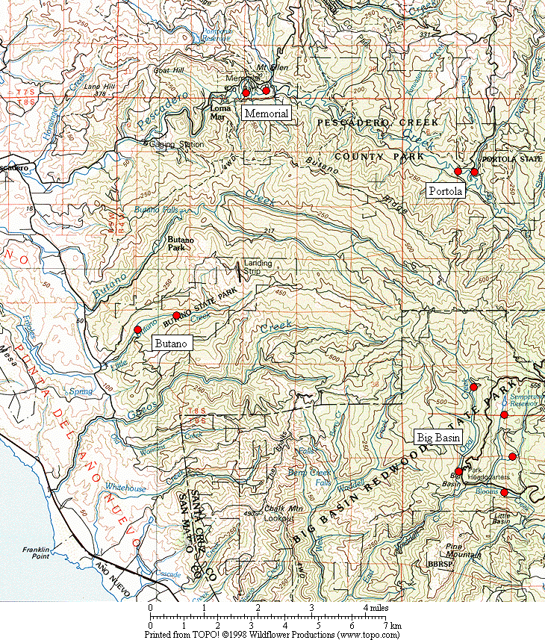

Figure 1. General location of the Marbled Murrelet monitoring stations in the four Santa Cruz Mountains parks.

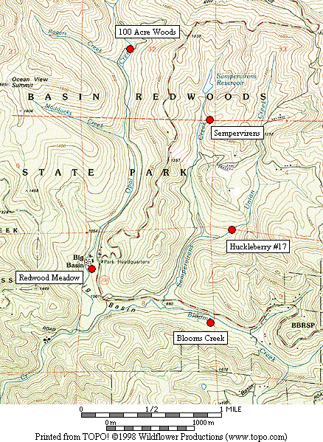

Figure 2. Location of Marbled Murrelet monitoring stations in Big Basin Redwoods State Park.

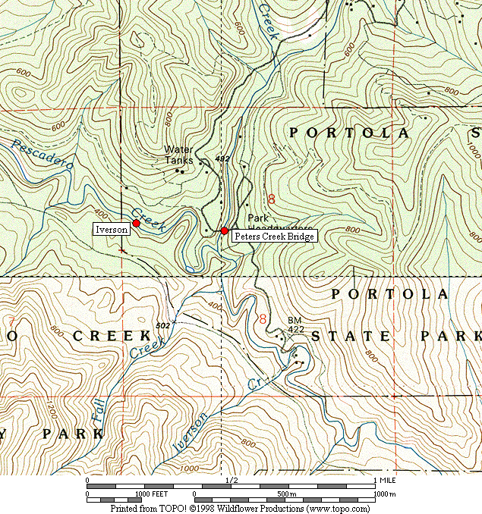

Figure 3. Location of Marbled Murrelet monitoring stations in Portola Redwoods State Park.

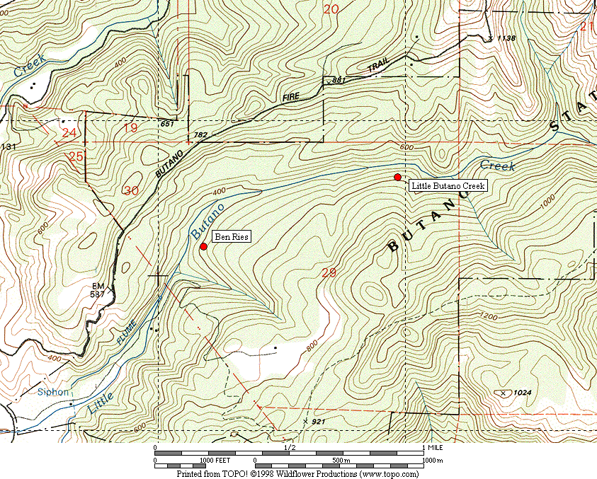

Figure 4. Location of Marbled Murrelet monitoring stations in Butano State Park.

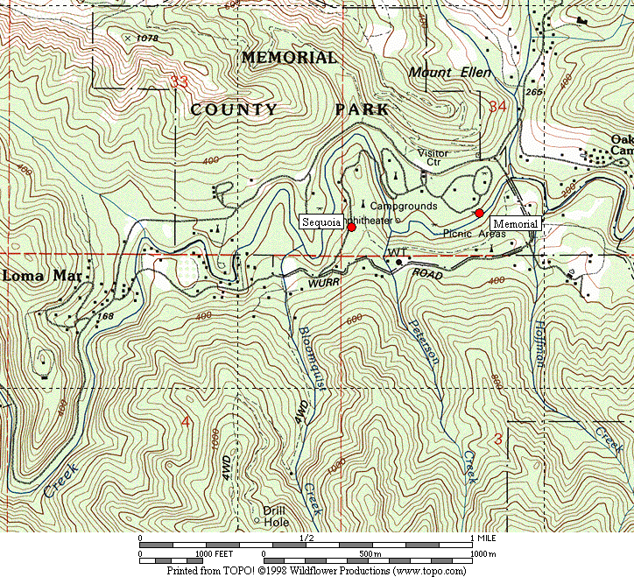

Figure 5. Location of Marbled Murrelet monitoring stations in San Mateo County Memorial Park.

Figure 6. Average murrelet activity on dawn surveys from all five Big Basin stations. (Note: no data from 1997, 1999 or 2000. See Table 2 for standard deviations.)

Figure 7. Average annual murrelet activity at all five Big Basin stations, showing total detections (± s.d) with linear regression trend. (Note: no data from 1997, 1999 or 2000.)

A. Redwood Meadow B. 100 Acre Woods

C. Blooms Creek D. Huckleberry #17 (Note: no
detections were recorded in 2002)

E. Sempervirens (Note: no
detections were recorded in 2002 or 2003)

Figure 8. Annual activity levels (average total detections) at individual Big Basin monitoring stations from 1995 – 2003. (Note: no data for 1997, 1999 or 2000.)

Figure 9. Average detections from dawn surveys on three consecutive mornings in late June or early July at “Peters Creek Bridge,” Portola Redwoods State Park, 1992-2003. (Note: no data from 1996, 1997, 1999, or 2000.)

Figure 10. Linear regression on average detections from dawn surveys in late June or early July at “Peters Creek Bridge” in Portola Redwoods State Park. (Note: no data from 1996, 1997, 1999, or 2000.)

Figure 11. Relative levels of Marbled Murrelet activity at each park in 2003.

Appendix 1. Bird species detected and point count maxima from 2003 dawn Marbled Murrelet surveys. (See footnote for key to station codes.)¹

Big Basin Portola Butano Memorial

Species RM BC HU OA SP PC IV BR LB ME SQ

Great Blue Heron – X² – – – – – – – – –
Wood Duck – – – – – – 1 – – – –
Common Merganser – – – – – X X – – – –
White-tailed Kite – – – – – – X – – – –
Sharp-shinned Hawk – 1 – – – 1 X – – – –
Cooper’s Hawk 1 1 X – – – X – – 1 1
Red-shouldered Hawk 1 – 1 – 1 1 1 X 1 2 2
Peregrine Falcon – – – – – – – – – – –
Marbled Murrelet ³ 5 1 2 3 – 8 16 10 3 2 4
Band-tailed Pigeon 1 3 3 2 1 3 1 2 6 3 2
Mourning Dove 1 – 1 – – – – – – – 2
Western Screech-Owl – X – X X – – – X – –
Northern Pygmy-Owl – – – – – – – – – – 1
Northern Saw-whet Owl – X – – – – – – – – –
Vaux’s Swift 1 – 1 – – 1 X – – – –
Allen’s Hummingbird X X 1 1 – X 1 1 2 X 1
Belted Kingfisher 1 – – – – – 1 – – – 1
Acorn Woodpecker 18 23 11 2 4 5 X 3 X 2 5
Hairy Woodpecker 2 1 1 X 1 2 1 2 2 1 2
Northern Flicker 1 2 – X 2 1 – 1 X – 1

Appendix 1, continued.

Big Basin Portola Butano Memorial

Species RM BC HU OA SP PC IV BR LB ME SQ

Pileated Woodpecker 2 3 3 2 2 1 – 2 2 X 1
Pacific-slope Flycatcher 3 2 1 4 4 4 2 3 3 2 4
Hutton’s Vireo 2 2 2 1 2 1 – – X X –
Warbling Vireo – – – – 2 – – – – – –
Violet-green Swallow – – – – – 1 X – – – 2
Steller’s Jay 7 8 19 2 3 6 5 9 5 8 23
Common Raven 2 1 3 2 2 19⁷ 1 1 2 3 4
Chestnut-backed Chickadee 4 4 5 5 4 4 2 4 4 5 5
Pygmy Nuthatch 5 7 3 2 4 4 4 3 2 3 4
Brown Creeper 2 3 2 3 4 4 3 2 3 3 3
Winter Wren 2 4 3 3 3 3 4 4 3 3 1
American Dipper – – – – – – – – – X –
Golden-crowned Kinglet 1 1 1 – 1 X 1 3 4 3 2
Hermit Thrush 4 3 1 2 2 1 1 X X – –
Swainson’s Thrush 1 – – – – 1 2 1 – 1 1
American Robin 2 3 3 1 1 3 X 2 2 3 6
Wrentit 1 3 – – – – – – 2 – –
Wilson’s Warbler 2 3 2 – 2 X 3 – 2 1 –
Spotted Towhee 1 2 3 – X – – – – – –
Black-headed Grosbeak X – 1 – – 1 – – – – –

Appendix 1, continued.

Big Basin Portola Butano Memorial

Species RM BC HU OA SP PC IV BR LB ME SQ

Dark-eyed Junco 4 1 1 X 2 2 – – – 3 2
Purple Finch 2 X X 1 1 X – X – – –
Red Crossbill – – – X – 1 – 1 X – X
Pine Siskin – – – – – 1 – X 1 1 3

1. Station codes: RM (Redwood Meadow), BC (Blooms Creek), HU (Huckleberry #17), OA (100 Acre Woods), SP (Sempervirens), PC (Peters Creek
Bridge), IV (Iverson Trail), BR (Ben Ries), LB (Little Butano Creek), ME (Memorial), SQ (Sequoia).
2. “X” denotes a species detected during a 2-hour survey, but not detected during any point count.
3. Number given for Marbled Murrelet is the best estimate from one or more detections during a point count.
4. Cumulative species detected from all dawn surveys.
5. Cumulative species detected from all 10-min. point counts (2 on each survey day).
6. Cumulative individuals from high counts during all point counts.
7. Flocks of 19 and 30 ravens flew over from some distant roost; the high count of “local” ravens on a point count at “Peters Creek Bridge” was 3.

